CPS2231 Assignment 1

1. (a)

In Java, a class is a blueprint or template that defines the characteristics and behavior of objects. It is a kind of abstract concept that represents the essential features of a group of real-world entities. A class contains variables (called fields or attributes) and functions (called methods) that describe the state and behavior of the objects.

An object is an instance of a class. It is a concrete realization of the class's template. Objects are created using the new keyword and the class's constructor. Each object has its own state, represented by its fields, and can perform actions, implemented by its methods.

(b)

The relationship between a class and an object is fundamental in object-oriented programming. The class defines the structure and behavior of a type of object, while an object is a specific instance of that type, with its own unique state and the ability to perform actions defined by the class.

1. Create a single dimensional array of type String called cars

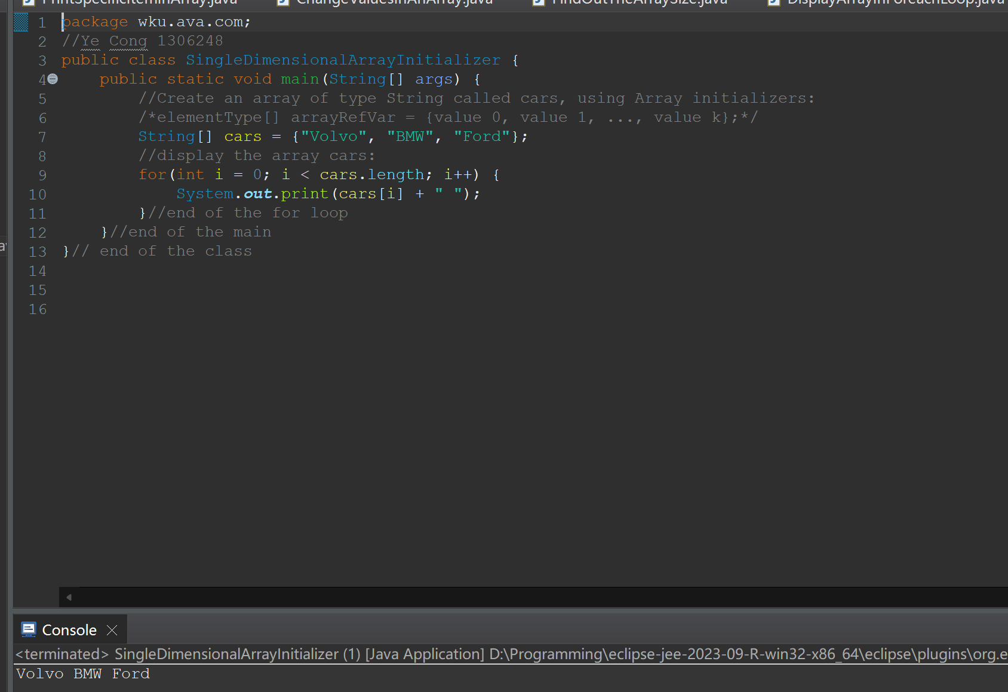

1. Print the second item in cars array

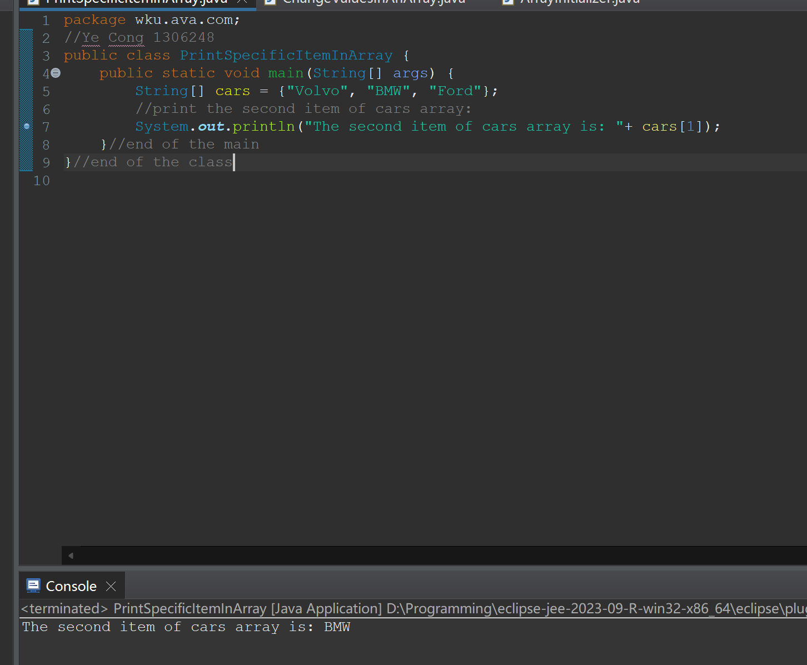

1. Change the value from “Volvo” to “Opel”, in the cars array

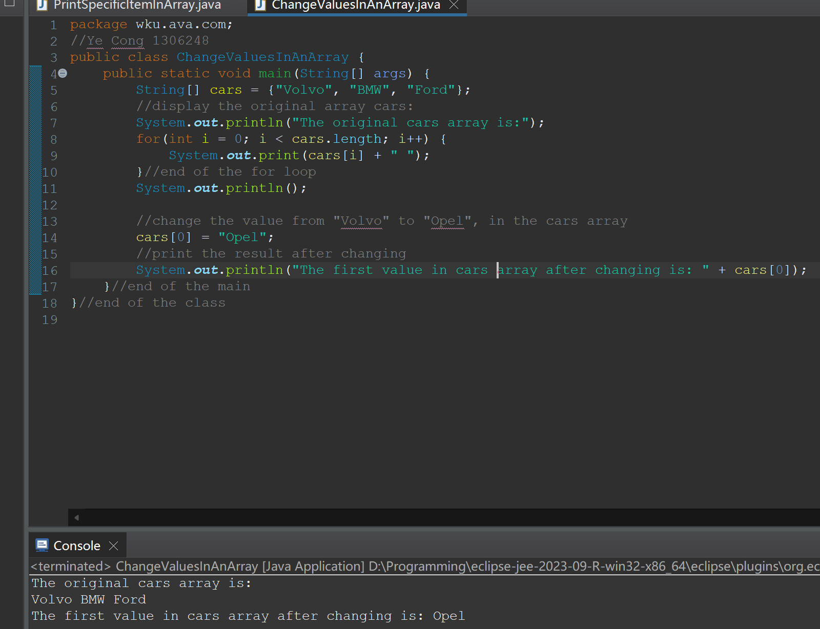

1. Find out how many elements in cars array have

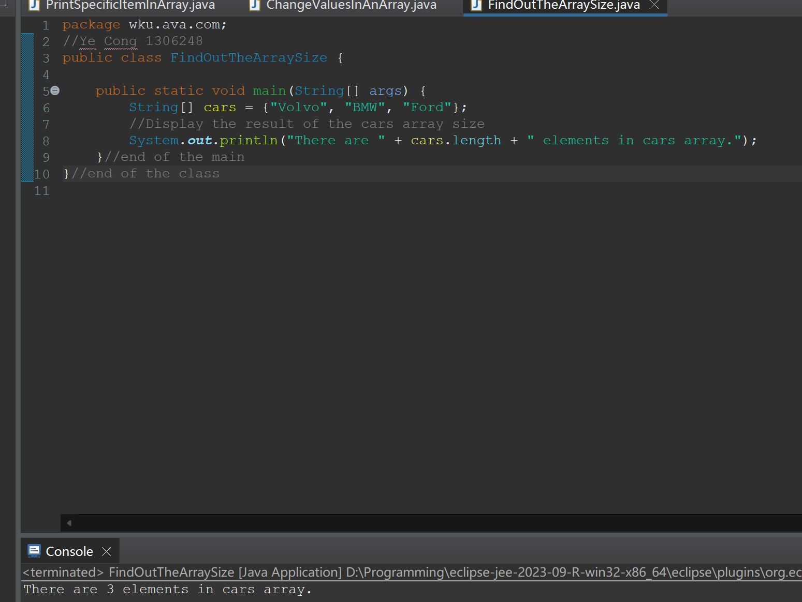

1. Loop through the items in cars array using foreach loop

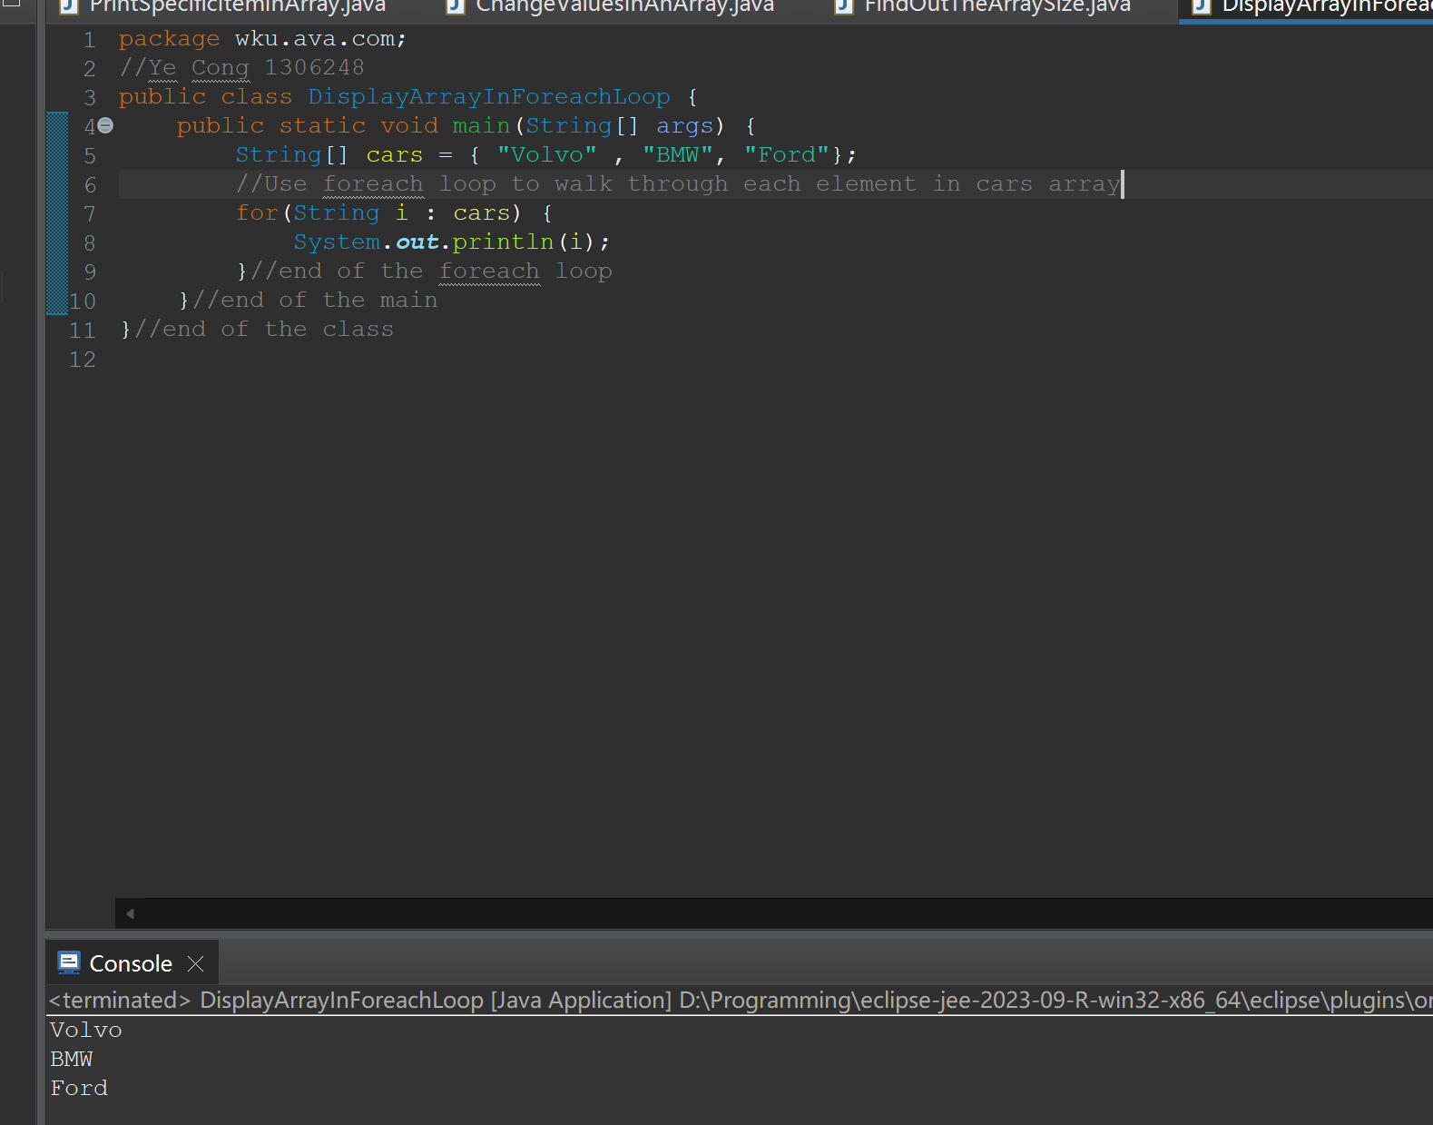

1. Loop through the items in cars array using for loop

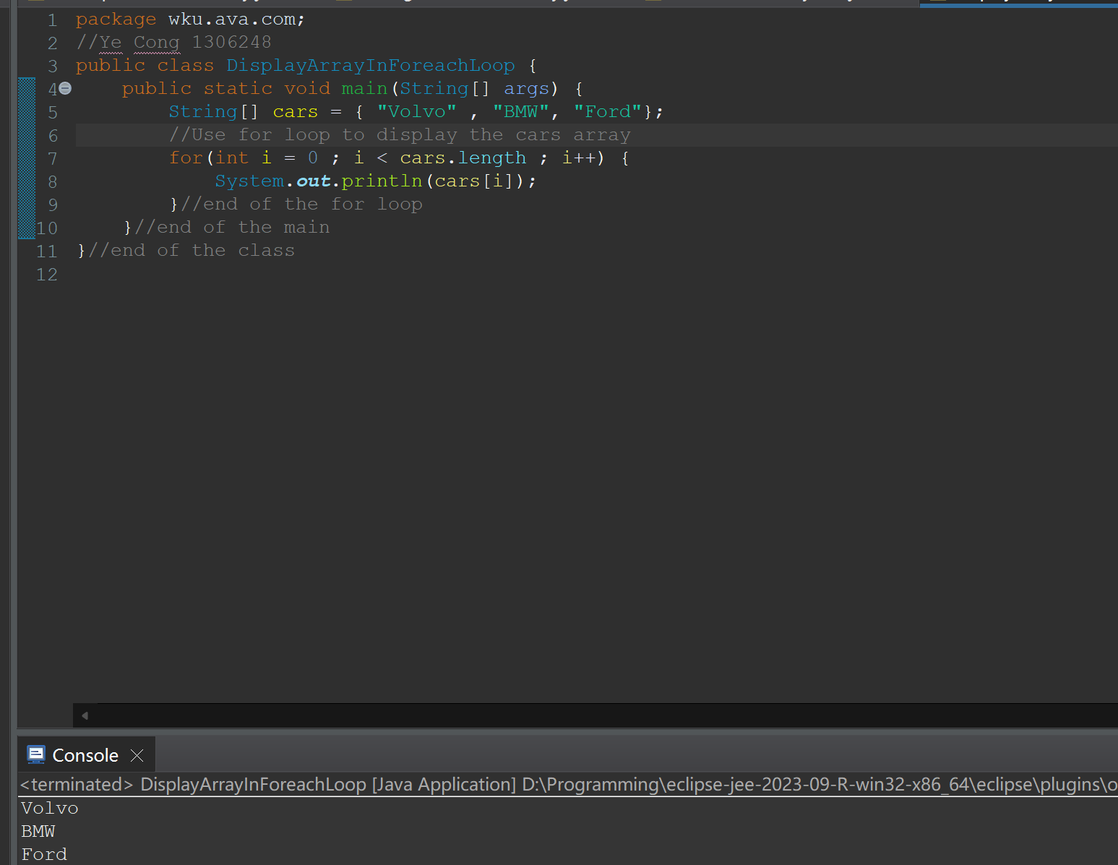

1. Create a two-dimensional array of type int called Mynumbers

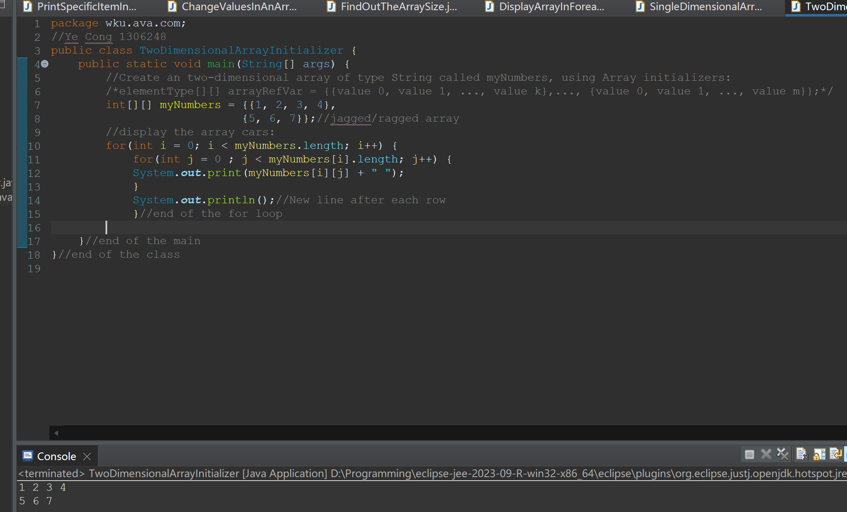

1. With the use of UML tool, construct the TV class diagram

And specify the properties as private data

